

Practices for Secure Software Report

Table of Contents
Document Revision History 3
Client 3
Instructions 3
Developer 4
1. Algorithm Cipher 4
2. Certificate Generation 4
3. Deploy Cipher 4
4. Secure Communications 4
5. Secondary Testing 4
6. Functional Testing 4
7. Summary 4
8. Industry Standard Best Practices 4

Document Revision History

Version | Date | Author | Comments
1.0 | 10/12/2026 | Brenda Cardenas

Client



Instructions

Submit this completed practices for secure software report. Replace the bracketed text with the relevant information. You must document your process for writing secure communications and refactoring code that complies with software security testing protocols.

- Respond to the steps outlined below and include your findings.
- Respond using your own words. You may also choose to include images or supporting materials. If you include them, make certain to insert them in all the relevant locations in the document.
- Refer to the Project Two Guidelines and Rubric for more detailed instructions about each section of the template.

Developer
Brenda Cardenas

Algorithm Cipher

For Artemis Financial, I recommend using the Advanced Encryption Standard (AES-256) to protect sensitive financial information. AES-256 is a strong encryption algorithm that helps prevent unauthorized access to confidential data. I also used SHA-256 hashing in the application to generate a checksum that can help verify data integrity. Unlike encryption, hashing is a one-way process and cannot be reversed to recover the original information. Using AES-256 for data protection and SHA-256 for integrity verification helps Artemis Financial improve its software security and reduce the risk of data being accessed or modified without authorization.

Certificate Generation
Insert a screenshot below of the CER file.

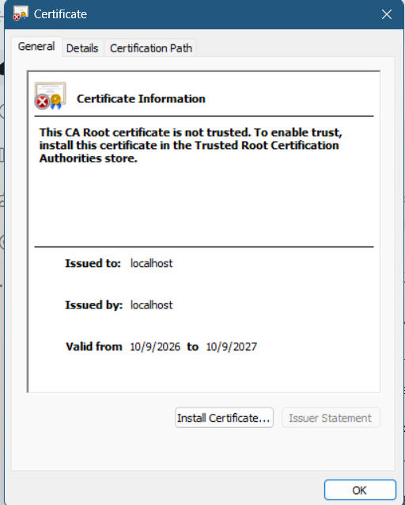

Deploy Cipher
Insert a screenshot below of the checksum verification.

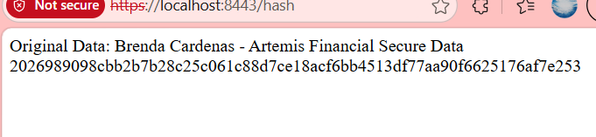

Secure Communications
Insert a screenshot below of the web browser that shows a secure webpage.

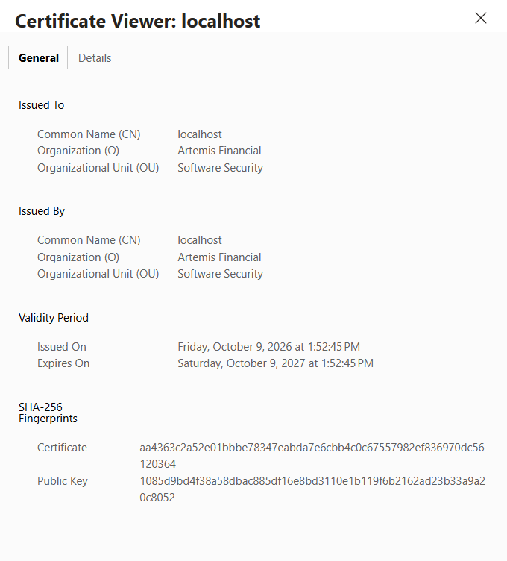

Secondary Testing
Insert screenshots below of the refactored code executed without errors and the dependency-check report.

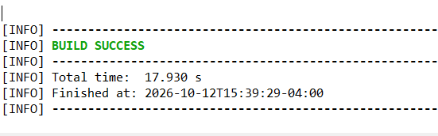

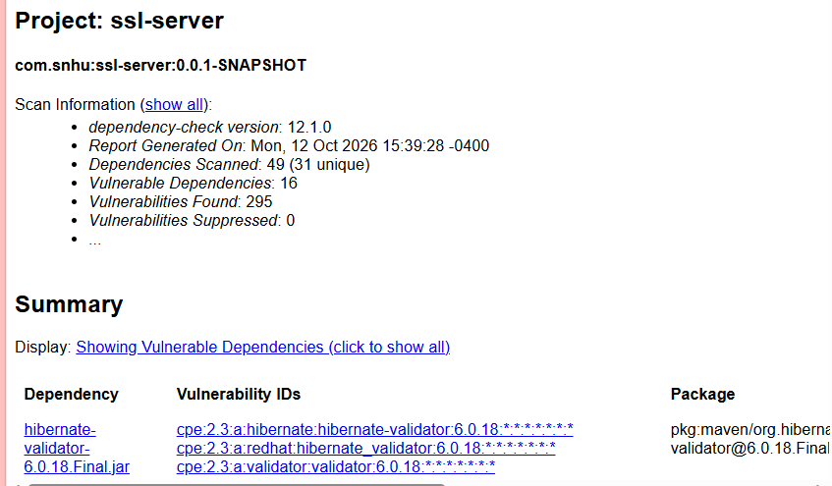

After making the security updates to the Artemis Financial application, I ran another OWASP Dependency-Check scan to identify possible vulnerabilities. The scan completed successfully and examined 49 dependencies, including 31 unique dependencies. The report identified 16 vulnerable dependencies and 295 reported vulnerabilities. These results show that although the application successfully completed the build and security testing process, some third-party dependencies still contain potential security risks. Additional updates and testing would be necessary to address these vulnerabilities and improve the application's overall security.

Functional Testing
Insert a screenshot below of the refactored code executed without errors.

I performed functional testing on the updated Artemis Financial application to verify that the changes did not interfere with its operation. The Maven build completed successfully, and the automated test results showed one test completed with zero failures and zero errors. I also verified that the application could display the original data and its SHA-256 hash through the HTTPS endpoint. These results confirm that the tested functionality continued to work after the security changes. However, the dependency scan identified additional vulnerabilities that would require further attention.

Summary

For this project, I improved the security of the Artemis Financial application by implementing SHA-256 hashing and enabling HTTPS communication with a self-signed certificate. These changes helped protect the integrity of the data and provide encrypted communication between the application and the browser. I tested the updated application and confirmed that the hashing feature worked correctly. The Maven build also completed successfully with no test failures. However, the OWASP Dependency-Check report identified 295 vulnerability findings across 16 dependencies, showing that additional security improvements are still needed. Overall, this project helped me understand the importance of secure coding, encryption, vulnerability testing, and maintaining software dependencies.

Industry Standard Best Practices

Throughout this project, I followed several industry-standard security practices to improve the Artemis Financial application. I used SHA-256 hashing to help verify data integrity and configured HTTPS with a self-signed certificate to encrypt communication between the application and the browser. I also used OWASP Dependency-Check to identify security vulnerabilities in third-party dependencies. These practices are important because they help protect sensitive information, reduce security risks, and identify weaknesses before software is released. In a production environment, I would use a certificate issued by a trusted certificate authority, update vulnerable dependencies, and perform additional security testing to strengthen the application's protection.

